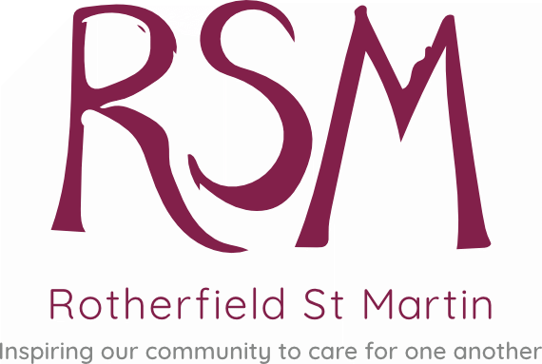

Memorial Institute, North Street, Rotherfield, East Sussex. TN6 3LX, Telephone (01892) 853021, Registered Charity No. 1168555
MEMBERSHIP FORM
BASIC INFORMATION
Full Name …………………………………………………………………………………………………………………..
Address……………………………………………………………………………………………………………………….…………..……………………………………………………………………………………………………………………….
Telephone (Home)…………………………………………………(Mobile)………………………………………
Email Address…………………………………………………………..Date of Birth……………………………..
Emergency contact Name and Number……………………………………………………………………….
GP and Surgery…………………………………………………………………………………………………………….
PERSONAL INFORMATION
Do you have and food allergies or other medical conditions that you think we should be aware of?....................................................................................................................
Are you a main carer for someone?................................................................................
PERMISSIONS AND AGREEMENTS
I give my permission for any photos taken by RSM to be used for publicity (this includes social media/newspapers/newsletters and marketing materials) Yes/No
I give my permission for RSM to send me or notify me of the following by either phone, post or email:
Newsletters Yes/No
Details of events (including fundraising), activities and services Yes/No
INFORMATION
We offer a Befriending service for members who may feel isolated or lonely, and who would like some companionship, would you be interested in this service? Yes/No
Privacy Notice: At Rotherfield St Martin we take your privacy seriously and will only use your personal information to provide the services you have requested from us and to enable us to support your welfare. Our record keeping systems including storing and information sharing, meet legal requirements within the framework of the Data Protection Act 2018 (GDPR). Our lawful basis and purpose for processing is ‘consent’ and ‘vital interests’. Our Data Protection Officer is Vicky Cheeseman. All information on this form is kept in the strictness of confidence and is stored in a lockable filing cabinet and on a secure password protected database. The information will be accessed by RSM staff and volunteers for the purpose of supporting and communicating with you, but may be disclosed to appropriate bodies/organisations who can offer further support. We will store your data for the length of or membership.
PAYMENT - Your membership gives you access to all RSM clubs, activities, outings, volunteer driver scheme for medical appointments, dementia support, therapists and exercise and hydrotherapy classes. Please speak to us for separate costs of these activities.
Annual subscription £26 (If you wish to pay in quarterly instalments please contact the office)
I enclose cash/cheque (made payable to Rotherfield St Martin) of £26.00
I will make payment via bank transfer:
Natwest Bank Sort Code: 60 06 27 Acc No: 33645590
GIFT AID IT - Charity Gift Aid – multiple donation
Boost your donation by 25p of Gift Aid for every £1 you donate
Gift Aid is reclaimed by the charity from the tax you pay for the current tax year. Your address is used to identify you as a current UK taxpayer.
In order to Gift Aid your membership fee/donation you must tick the box below.
I want to Gift Aid my donation of £ and any donations I make in the future or I have made in the last 4 years to Rotherfield St Martin
I am a UK tax payer and understand that if I pay less Income Tax and/or Capital Gains Tax than the amount of Gift Aid claimed on all my donations in that tax year it is my responsibility to pay any difference. I confirm my details as overleaf.
Please notify us if you wish to; cancel this declaration; change your details; no longer pay sufficient tax on income and or capital gains.
Signed: Dated:

