General Update and NHS App News

NHS App

(Please note: Make sure you have the right App – NHS App, not the test and trace one. Also note that there is quite a lot of enter this p/w and that one and second confirmation via phone etc etc!) Andy

The NHS App will be available to use as a vaccine passport from Monday 17 May 2021.

A paper version will also be available by calling 119.

You do not need to telephone your GP Practice to ask about the vaccine passport as they are unable to provide vaccine passports and it’s essential we leave phone lines free for people who need medical assistance.
The NHS App is separate to the NHS COVID-19 App, which is used for contact tracing.

You can already use the NHS App to book appointments, repeat prescriptions and see your full medical records.

Your vaccine passport will only show when you have had both doses.

If you don’t have the NHS App, download the NHS App now. It will record when you have had both doses of the vaccine and automatically create a vaccine passport which will be available from Monday 17 May 2021.

If you already have the NHS App, it will record when you have had both doses of the vaccine and automatically create a vaccine passport which will be available from Monday 17 May 2021. You do not need to do anything.

If you have the NHS App and get a message to say you need to contact your GP Practice, this is an extra option to get full access to your medical records in the NHS App. To get access to your full medical records in the NHS App, you need to contact your GP Practice and request access to your detailed coded record. Please avoid calling your GP practice at peak hours when people are trying to book appointments, and if possible email the team. The GP Practice will take appropriate time to action your request. This is completely separate from the vaccination information and will not affect your access to the vaccine passport.

If you are planning to travel, please register to use the NHS App at least two weeks before travelling.
The paper letter should be requested at least five days after a second vaccine, and can take up to five days to arrive so make sure to leave plenty of time if you need it to travel.
You can read more:

- NHS App help and support
- Demonstrating your vaccine passport

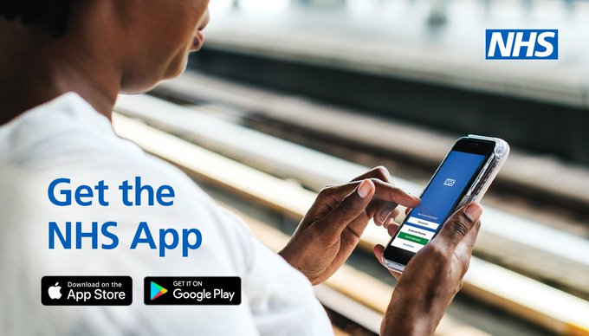

Please see below for a News Release.

More than 600,000 NHS Covid Jabs Booked in 48 Hours

More than 600,000 appointments for a lifesaving Covid jab were booked in just 48 hours after the NHS vaccination programme was opened up to people in their thirties.

Those aged 38 and 39 have been able to arrange a jab through the National Booking Service since Thursday.

Since then, 611,863 first and second dose appointments have been booked at a NHS Vaccination Centre or local pharmacy-led vaccination service

Younger people in their thirties are expected to be invited over the next few days and weeks.

The surge in bookings comes as more than two thirds of people aged 50 and over have been fully vaccinated after receiving both doses.

More than three quarters of those aged 40 to 49 have also received their first doses just a fortnight after they were offered a jab by the NHS.

In all, 30 million people have been protected with a first dose in England, two thirds of the total adult population.

One in three people, around 15 million, have had both doses giving them maximum protection from the virus.

The Government and the JCVI announced on Friday that second dose appointments will be brought forward from 12 to 8 weeks for those aged 50 and over who have yet to received theirs.

Nobody needs to contact the NHS.

Those who have their second dose booked in the next ten days, up to and including 24 May, should attend their appointment as planned.

People who should have their second dose brought forward do not need to contact the NHS. The NHS will let them know when they can rebook.

NHS national medical director Professor Stephen Powis said: “Six months into the NHS Covid vaccination programme bookings are still surging, with more than 600,000 jabs booked in just 48 hours.

“The success of the programme, the biggest in NHS history and one of the fastest and most precise in the world, is no accident but the result of extensive planning and the sheer hard work of nurses, doctors and countless other staff supported by our brilliant volunteers.

“On the advice of the Government and JCVI people aged 50 and over and the clinically vulnerable are having their second doses brought forward to counter the spread of the Indian variant.

“People should continue to attend their second dose appointments, and nobody needs to contact the NHS – we will let those who should bring their appointment forward know, when they are able to do so.

“Getting the vaccine is the single most important step we can take to protect ourselves, our families and our communities against Covid 19, so when you’re called forward, book your appointment and join the tens of millions who have already been jabbed.”

The NHS made history when Maggie Keenan became the first person in the world to be protected against coronavirus outside of a clinical trial when she received the Pfizer vaccine at Coventry Hospital on 8 December.

The health service in England also delivered the first Oxford / AstraZeneca jab to Brian Pinker the following month and is now also using Moderna. All three vaccines have been approved as safe and effective by the world leading medical regulator the MHRA.

Vaccinations are being administered at more than 1,600 sites across the country, including mosques, museums and rugby grounds, meaning the vast majority of the people live within 10 miles of at least one vaccination service.

People invited through the National Booking Service are offered a choice of appointments at NHS Vaccination Centres or pharmacy-led vaccination services, as well as some GP-led sites.

Text invitations appear as an alert from ‘NHSvaccine’, including a web link to the NHS website to reserve an appointment.

People 39 and under without an underlying health condition will be offered the Pfizer or Moderna vaccine in line with updated JCVI guidance last week.

Pregnant women using the service will also be directed to vaccination centres offering Pfizer and Moderna in their local area in line with JCVI Guidance.

They can also speak to their GP practice or maternity service if they have any questions about the coronavirus vaccine or can talk to a healthcare professional at their appointment

People who cannot go online can call the service on 119 instead to book their jab.

The NHS is also sending text reminders to people who have not yet taken up their offer of jab and also to people overdue their second dose to ensure nobody is left behind.

Andy Miller

