Vaccination News 14 April
People aged 38 and 39 now eligible for vaccination

The NHS Covid vaccination programme, the biggest in health service history, has opened today to people in their thirties.
People aged 38 and 39 are now eligible.
The national booking system is updatd and GP led local vaccination services are also able to call in this group for appointments, in line with vaccine supply.
The move to the next age group comes as nearly three quarters of people aged between 40 and 49 have had their first dose, less than a fortnight after they were offered a jab.
Second dose appointments continue to be delivered across our vaccination sites, and we encourage everyone to make sure you attend your booked appointment to ensure you receive the maximum protection from these vaccines.

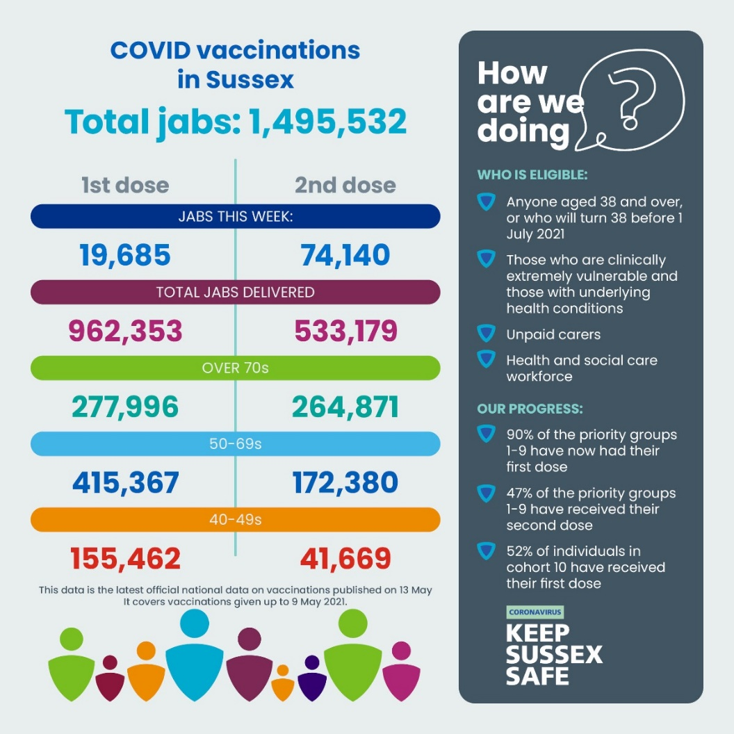

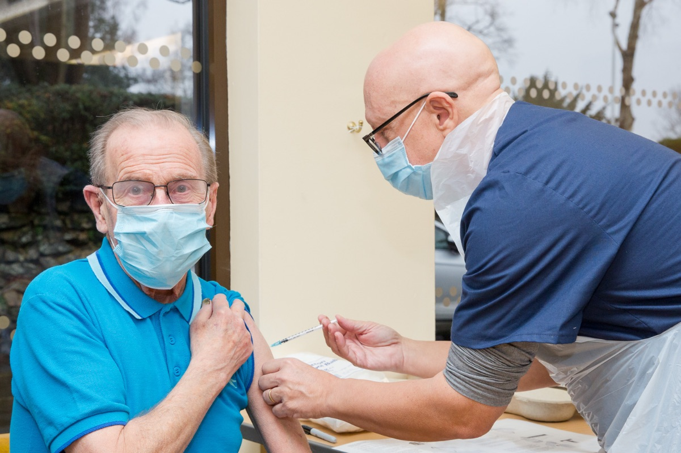

Teams vaccinating residents in care homes across Sussex have now visited 641 (85%) of homes (as at 11 May 2021) - giving some of the most vulnerable people in our communities maximum protection from the virus.
Care home residents and staff were prioritised after being identified in the top priority groups by the Joint Committee on Vaccinations and Immunisations, due to their high risk from COVID-19. Second doses are scheduled up to twelve weeks after the first and provide the most protection possible by reinforcing the recipient’s initial immune response triggered by the first vaccine.
In Sussex we have one of the highest numbers of nursing and care homes per capita across the country and so the work of the vaccination teams from local GP practices and Sussex Community NHS Foundation Trust is a significant undertaking.
In addition, those people registered as housebound in Sussex - either living in their own homes or a form of supported housing such as Extra Care – have also now begun receiving second doses of the vaccination.
Visiting loved ones in care homes
Alongside other protections in place, vaccination of both residents and staff in care settings as well as an overall reduction in COVID-19 cases, has helped to enable further easing of visiting restrictions for families and friends of those living in care.
From Monday 17 May 2021, the number of named family members or friends able to visit their loved ones in care homes will be increased from two to five. A maximum of two visitors will be allowed at any one time or on any given day.
Residents will also be able to go to medical appointments, a workplace, educational setting and day centres without having to self-isolate on their return.

I am now eligible and have gone online to book my appointment but can only see vaccination centres in London, do I have to travel that far?
The National Booking System both online at nhs.uk/covidvaccine or over the phone by calling 119 only shows services with available appointments. If a vaccination centre or service currently does not have any available appointments it will not show up in the list when you log into the system.
Currently there are a limited number of first dose appointments available in Sussex in line with vaccine supply. We have been assured that this is a short-term issue and we encourage eligible people who have been invited to receive their vaccination to keep checking the National Booking System for appointments.
This is only in relation to first dose appointments and second dose vaccination deliveries are continuing across Sussex and we encourage everyone to attend your second dose appointments when it is your turn.

Find out more about the NHS app - and how you can help without calling your GP practice

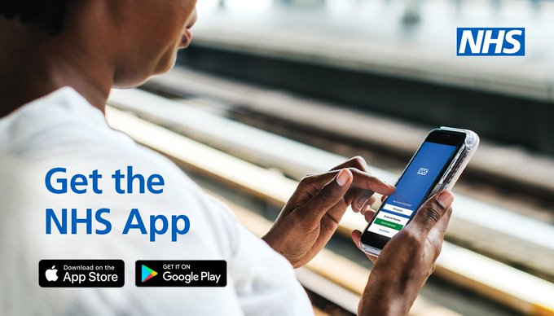

People are being urged not to call their GP practice about vaccination information on the NHS App.
This week it has been announced that the NHS app will be available to use as a vaccine passport from Monday 17 May 2021. A paper version will also be available by calling 119.
You do not need to telephone your GP Practice to ask about the vaccine passport as they are unable to provide vaccine passports and it’s essential we leave phone lines free for people who need medical assistance.
The NHS App is separate to the NHS COVID-19 App, which is used for contact tracing.
Your vaccine passport will only show when you have had both doses.
If you don’t have the NHS App, download the NHS App now. It will record when you have had both doses of the vaccine and automatically create a vaccine passport which will be available from Monday 17 May 2021.
If you already have the NHS App, it will record when you have had both doses of the vaccine and automatically create a vaccine passport which will be available from Monday 17 May 2021. You do not need to do anything.
If you have the NHS App and get a message to say you need to contact your GP Practice, this is an extra option to get full access to your medical records in the NHS App. It does not relate to the vaccination information. If you need this level of access please contact your GP practice outside of peak hours or by email or letter in order to keep their phone systems clear for people that need medical help.
If you are planning to travel, please register to use the NHS App at least two weeks before travelling.
The paper letter should be requested at least five days after a second vaccine, and can take up to five days to arrive so make sure to leave plenty of time if you need it to travel.
You can read more:
- NHS App help and support
- Demonstrating your COVID-19 vaccination status when travelling abroad - GOV.UK (www.gov.uk)

And don’t forget, any queries/help, contact Andy Miller:
01892 852 389; 07817 130 653 E-Mail vaccinationchampion@gmail.com

